**CORNMEAL**

**HERO**

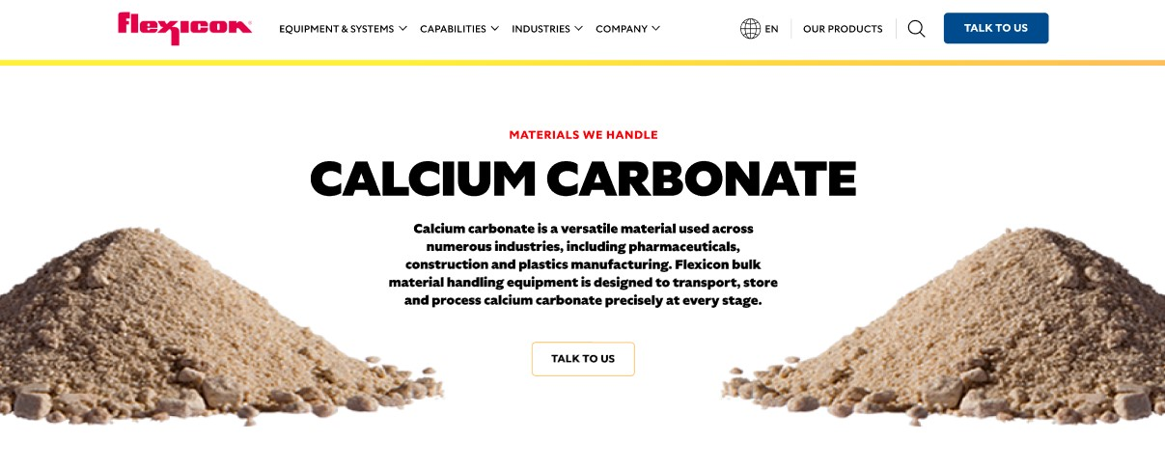

Cornmeal is a staple ingredient in global cuisine, used in everything from tortillas to baked goods. Cornmeal’s versatility and nutritional value make it a reliable choice for commercial food production. Flexicon bulk material handling systems are engineered to move cornmeal efficiently, safely, and cleanly without compromising product integrity.

B**utton**: Talk To Us

**SHELF #1 - PRODUCT DESCRIPTION**

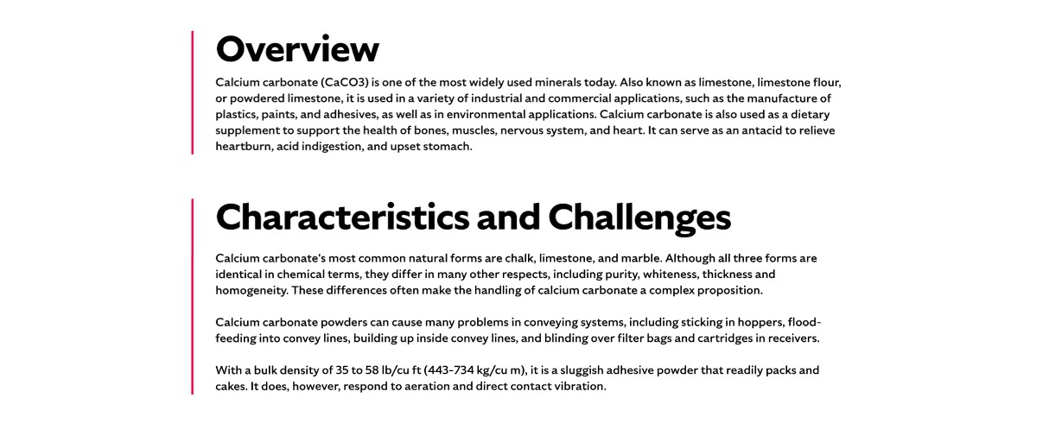

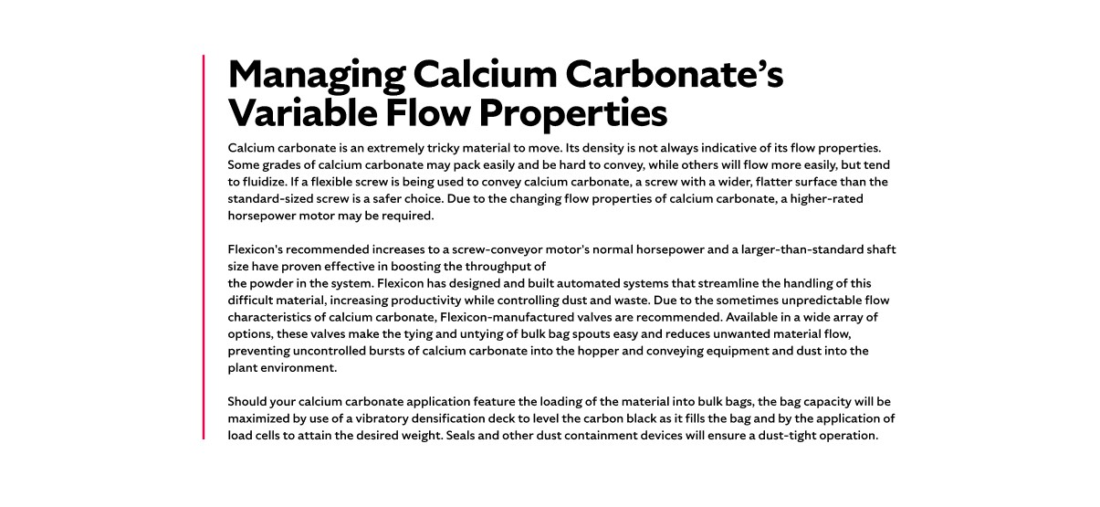

**Overview:**Also known as Indian meal, cornmeal is made by grinding whole corn kernels into smaller particles using either traditional stone mills or modern steel grinders. Stone-ground cornmeal retains more of the hull and germ, offering enhanced flavor and nutrition, while steel-ground cornmeal provides a longer shelf life. Cornmeal is a key ingredient in tortillas, cornbread, muffins, fritters, and hush puppies, and is also used in mixes for cereals, pancakes, and snacks.

**Characteristics and Challenges**

Cornmeal is available in a wide range of grades and granulations, including finer forms like corn cones used in bakery mixes and as a dusting meal. Most varieties have an average bulk density of 40 lb/cu ft, and their flow properties can vary significantly depending on particle size and moisture content.

Cornmeal’s fine particles can segregate during processing, leading to inconsistent product quality. Additionally, cornmeal dust is combustible, making dust containment and explosion prevention critical in handling systems.

**SHELF #2 - FLEXICON SOLUTIONS**

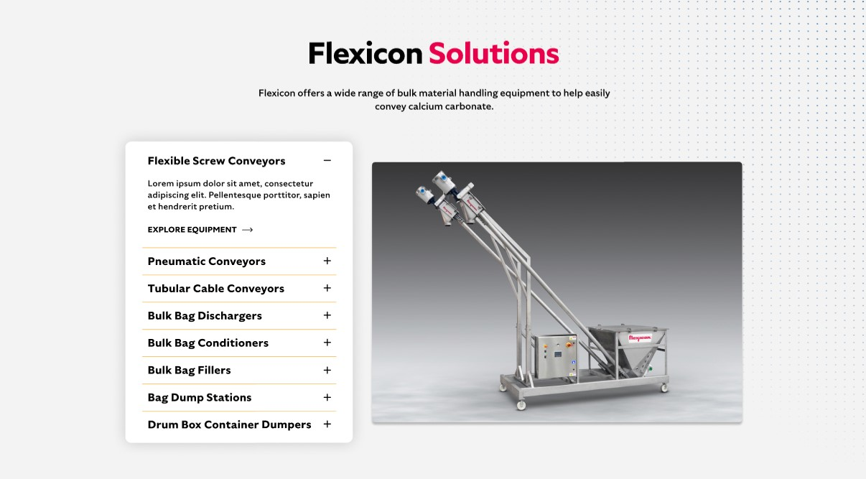

**Flexicon Solutions**

Flexicon offers a wide range of bulk material handling equipment to help easily convey calcium carbonate.

* **Flexible Screw Conveyor**: Ideal for conveying cornmeal with varying particle sizes and densities without separation or degradation.
* **Pneumatic Conveyors**: Efficiently move cornmeal through enclosed systems while minimizing dust and contamination risks.
* **Tubular Cable Conveyors**: Gently convey cornmeal blends without separation, preserving product integrity.
* **Bulk Bag Dischargers**: Discharge cornmeal from bulk bags completely using spring-loaded frames and bag activators to promote flow and reduce waste.
* **Bulk Bag Conditioners**: Loosen compacted cornmeal in bulk bags for smoother discharge and consistent flow.
* **Bulk Bag Fillers**: Fill bulk bags with cornmeal cleanly and efficiently, minimizing dust and maximizing throughput.
* **Bag Dump Stations**: Support manual unloading of smaller cornmeal bags with integrated dust collection and safety screening.
* **Drum Box Container Dumpers**: Empty cornmeal from drums or boxes into processing systems with minimal dust and operator exposure.

**SHELF #3: LIFETIME PERFORMANCE GUARANTEE**

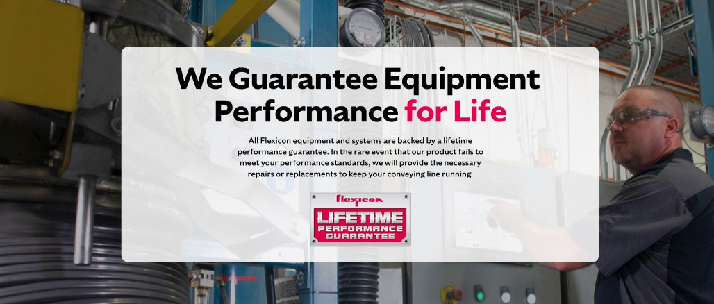

**Lifetime Performance Guarantee**

All Flexicon equipment and systems are backed by a lifetime performance guarantee. In the rare event that our product fails to meet your performance standards, we will provide the necessary repairs or replacements to keep your conveying line running.

**SHELF #4: CASE STUDIES**

